Body Vantage Notes

Main Page

Move the privacy to be at the bottom so it doesn't cover the page

Move the Bodyvantage and search button to be centre of the screen

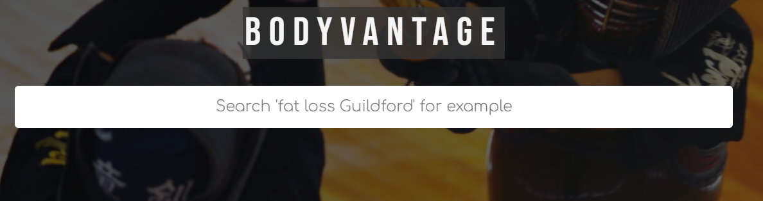

After Clicking search

Settings for google profile wording to be changed

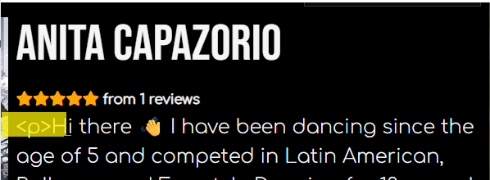

Under profile

Have the photo to be below the name

Change the size the name , bio reviews to be smaller

On the picture can you do a arrow on picture to get to the next picture

Reviews to be discussed

To be moved below the photo

Contact Page

Need to setup an email address
Change Name to Full Name

Setting

Load new clients but it does not save as I entered the details.
Search the new clients and it does not show the new clients

